CTIS Senior Project Proposal Form
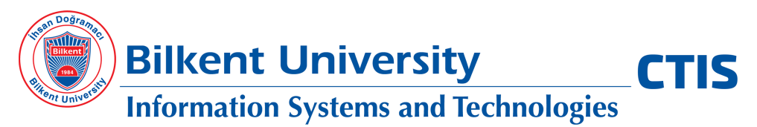
Date :
Company/Organization :
Address :
Sponsor Name :
Phone Number :
Email :
Project Name :

Please fill-out the following sections. You may extend the blank spaces as necessary. Please also note that, our students will use GitHub during software development, and our department will download and keep all project documents and code for assessment purposes. If you have any questions, please send an email to ctis-project@bilkent.edu.tr. You may submit your project proposals to the same email address by June 27, 2022.

Project Purpose
(Please describe the reasons or the need for proposing this project)

Product Scope and Requirements
(Please describe who the users of this product will be and the required features)

Software or Hardware Requirements
(Please describe if there are any restrictions on the software development or product operating environment such as Android, Oracle, etc. Also, please indicate if any special software and/or hardware is required for this software product such as a drone)

ctis.bilkent.edu.tr | @CTISBilkent | phn: 00 90 312 2665907 | fax: 00 90 312 2665908

